Dieting System Based on Disease
AIM:
To write a Prolog program to suggest a suitable diet based on a person's disease.
ALGORITHMS:
- Start.
- Define facts representing diseases and their recommended diets.
- Define rules to associate each disease with a suitable diet.
- Accept the disease name as input.
- Search the knowledge base for the corresponding diet.
- Display the recommended diet if a matching rule is found.
- If no matching diet exists, display a message indicating that no recommendation is available.
- Stop.

CODE:
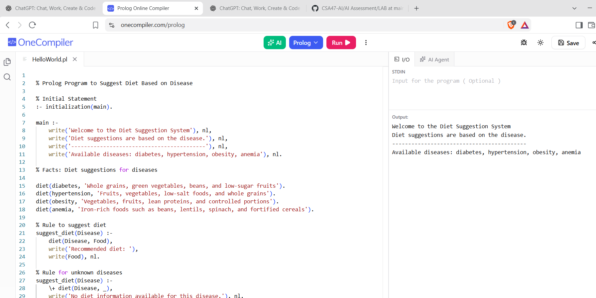
RESULTS:
The program suggests a diet based on the disease specified in the database.

